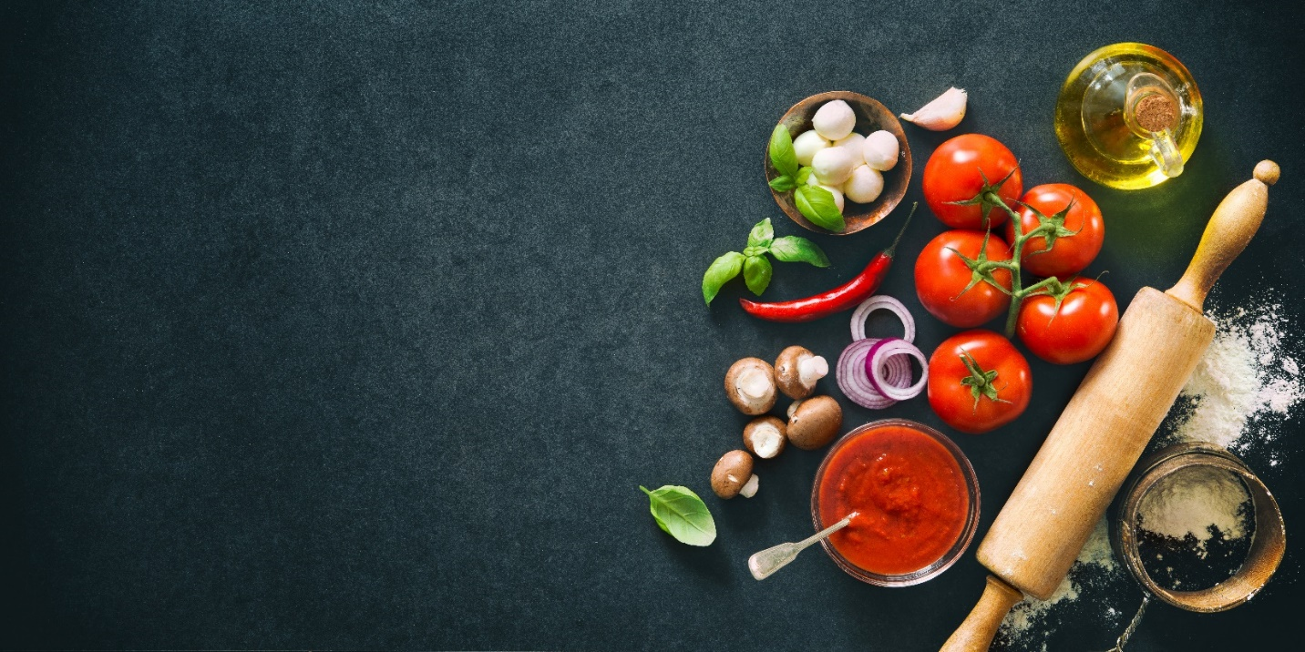

‘Made From Scratch’ Monthly!

This month we’re focusing on pantry basics. We’ve provided recipes, resources, and information to help you (and your family) prepare meals with limited ingredients and trips to the store.

**Cooking From Your Pantry!**

Looking for ways to reduce your trips to the grocery store? Get creative with what you have on hand.

* **Check the fridge, freezer and pantry for foods that need to be used**. Leftover meat and veggies can be used in soups, salads or sandwiches. Freeze leftovers that won’t be eaten before they spoil to use as a meal later.
* **Beans**: Use them in soups, dips and salads. This guide shows you [how to cook dried beans](https://goop.com/food/recipes/spilling-the-beans/).
* **Canned Vegetables**: Add to soup, rice, pasta or sauces
* **Bread or Tortillas**: If you don’t use them daily, store in the freezer
* **Oats**: Make oatmeal for a quick breakfast or try making these [no bake oatmeal energy balls](https://www.blessthismessplease.com/8-no-bake-oatmeal-energy-balls/) for a great kid friendly snack

**Check out these apps:**

* [**My Fridge Food Recipes**](https://apps.apple.com/us/app/my-fridge-food-recipes/id1382149985) - Enter the food items you have in your kitchen for a list of recipes you can make with some or all of the items.
* [**SuperCook: Recipes By Ingredient**](https://play.google.com/store/apps/details?id=com.supercook.app&hl=en_US) - Find recipes you can make right now, with the ingredients you already have at home.

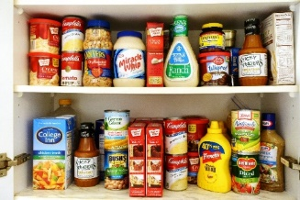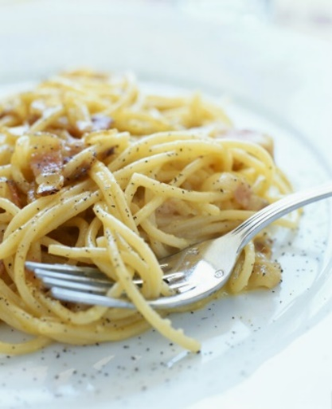

**Fresh, Canned or Frozen?**

**Fresh:** Many nutrients are highest at the moment the fruits or vegetables are picked and then start to degrade with time. If it’s fresh but has been shipped a long distance it will have lost some of its nutrients. Same is true if you buy a picked-that-morning lettuce from your farmers market and let it sit in your fridge for several days.

**Canned:** Produce is cooked as part of the canning process, so it is often lower in water soluble vitamins. Although, some vitamins are intensified by cooking; for example, canned peas have three times the vitamin A of fresh uncooked peas. When buying canned fruit, look for fruit in fruit juice vs in syrup.

**Frozen:** Produce is frozen soon after picking, so a lot of the nutrients are locked in. Since it stays frozen until you are ready to use it, it often has more nutrients than some fresh produce that has been sitting for a week. The texture of frozen produce is different so it works better in some dishes than in others.

**[Check out these recipes your kids can make on their own](https://www.tasteofhome.com/collection/easy-recipes-for-kids-to-make-by-themselves/)**

**Peanut Butter Chocolate Mug Cake**

**Ingredients**

* 3 Tbsp peanut butter, chunky or creamy
* 1 tsp cocoa powder
* 1 Tbsp sugar
* 1 egg

**Instructions**

1. Whisk together ingredients

in a microwave safe mug.

1. Microwave for 1 minute.
2. Enjoy!

**Tuna Salad**

**Ingredients**

* Two 6 oz cans white meat tuna packed in water, drained
* 2 Tbsp minced celery
* 2 Tbsp minced red onion
* 1 tsp parsley
* 1/3 cup mayonnaise
* 1 Tbsp whole-grain mustard
* Pepper for seasoning
* Lemon juice, optional

**Instructions**

1. In a small bowl break up the tuna with a fork. Toss with the celery, onion and parsley.
2. Add the mayonnaise, mustard and season with pepper to taste. Stir to combine. Add lemon juice if desired.

**Spicy Three-Bean Pantry Chili**

**Ingredients**

* 3 Tbsp vegetable oil
* 3 Tbsp tomato paste
* 1 Chipotle pepper in adobo sauce, smashed with a fork into a fine paste
* 3 Tbsp chili powder
* 1 tsp dried oregano
* Two 16 oz jars mild salsa (about 3 ½ cups)
* Three 15 oz cans of beans, such as kidney, black and pinto beans, or your preference, drained but not rinsed
* 15 oz can of corn, drained but not rinsed
* 1 cup long-grain rice
* ¼ cup cider vinegar
* 1 ½ cups water

**Instructions**

1. Heat the oil in a medium pot over medium-high heat. Add the tomato paste and cook, smearing and stirring constantly with a heat-proof spatula or flat-edged wooden spoon, until dark and aromatic, about 90 seconds.
2. Add the chipotle, chili powder and oregano, and cook, stirring, for 1 minute.
3. Stir in the salsa and 1 ¼ cup water. Stir in the beans and corn. Bring to a boil, reduce the heat to medium-low, cover and simmer for 25 minutes, stirring occasionally.
4. Meanwhile, cook rice based on instructions. Set aside.
5. Remove chili from heat, stir in the cider vinegar and let stand 1 minute.
6. Fluff rice with a fork. Serve chili over the rice.

**Easy Recipes Using Ingredients From Your Pantry:**

**Pasta Carbonara**

**Ingredients**

* 8 oz spaghetti or any pasta you have
* 2 eggs
* ½ cup parmesan cheese
* 4 slices of bacon, diced
* Garlic (as much as you would like)
* Italian seasoning to taste

**Instructions**

1. Boil pasta based on instructions, drain.
2. In a small bowl, whisk together eggs & parmesan cheese.
3. Cook bacon in a pan until brown and crisp. Remove from pan but don’t throw out the grease!
4. Add egg mixture to bacon pan, stir in garlic and quickly stir in the pasta. The heat from the pasta and bacon grease will cook the eggs.
5. Sprinkle with Italian season and enjoy!